|  |
| --- |
| Kennebec Regional Reentry Project  (KeRRP)  Participant  C:\Users\MPS\AppData\Local\Microsoft\Windows\Temporary Internet Files\Content.IE5\4IFKRBOA\MC900439613[1].pngHandbook |
| 2011 |

Pro-social

Pro-social behavior refers to the voluntary activities that we engage in that have a beneficial impact on society. It is our selfless actions that demonstrate empathy for others; for their rights, their welfare, and the greater good of the community. It can be as simple as participation in a neighborhood sports league, or as involved as a regular commitment to a community service organization.

Table of Contents

Introduction - 3

Program Description – 4, 5

Eligibility - 6

Client’s Rights - 7

Client’s Responsibilities - 8

Responses - 9

Substance Use - 10

Substance Testing - 11

Discharge from Program - 12

Home and Activity Visits - 13

Friends and Associates - 14

Program Completion - 15

In Conclusion - 16

Appendix A, Phases of Supervision – 17-20

Appendix B, Acknowledgements - 21

Introduction

The Kennebec Regional Reentry Project (hereafter referred to as KeRRP) is a five agency cooperative designed to assist adult offenders reenter society under a Community Confinement Monitoring contract. As a participant you will work with your case manager for a period of 6 months. The program is designed to encourage and develop self-sufficiency, and support you in your efforts toward achieving a fulfilling life as a responsible member of the community. Program participation is 100% voluntary and requires a commitment to pro-social choices that can include:

* living drug and alcohol free
* service to the community
* financial responsibility
* Restorative Justice practices
* personal growth and development
* healthy recreation and pastime

Making a decision to participate in this program demonstrates a courageous commitment to change. It’s not going to be easy; nothing worth doing ever is. KeRRP team members will be there to help you get by the most challenging obstacles, but the final responsibility for success is yours alone.

Program Description

KeRRP is a special community reentry program for selected participants who show a willingness to change the behaviors that lead to incarceration. Participants will be required to:

* contact their case manager daily by telephone
* report in person on a regular basis
* submit to regular and random substance screening
* attend agreed upon self-help meetings
* commit to agreed upon community service
* achieve agreed upon developmental objectives

Perhaps the most challenging requirement will be facing the past to help facilitate change for the future; acknowledgement of past deeds, and the acceptance of ownership for damage caused by criminal activity.

When you agree to participate in the program, you and your case manager sit down and develop a comprehensive release plan. (*You should make a list of questions and concerns prior to meeting with your case manager.)* This plan will outline our expectations regarding your objectives and activities. It will also outline what you can expect in support of your transition toward a more pro-social lifestyle.

While you are still in custody your KeRRP case manager will go over the terms of your release contract, establish a baseline for substance screening, and ensure that you have the necessary supports in place to reenter the community.

Once you are released you will be supervised in graduating phases of expectation (*as outlined in Appendix A*). You will be allowed to continue treatments, go to work, enroll in educational programs, attend self-help meetings, serve the community, and participate in approved pro-social activities while living at home. You must follow an approved schedule and make yourself available for monitoring at all times. It’s important for you to understand that you are still serving a sentence, and failure to follow the terms of your release can result in further charges being brought against you under Maine law.

We understand that this is going to be a difficult transition, perhaps the most challenging period of your life. We want you to know that we are not going to let you begin this journey alone. We will work to guide you toward the life that you desire. Upon completion of this program you will begin to recognize pathways that lead to success, and overcome the obstacles that set you back.

Eligibility

Program participants must meet all of the following eligibility requirements for release under KeRRP:

* Participant must have a split sentence.
* Participant must have 60-364 days remaining in custody after serving at least one-third of his/her sentence.
* Participant is not serving a sentence for a sex offense or a sexually violent offense as defined under Title 34-A, section 11203.
* Participant must agree to monitoring for 6 months or the remainder of his/her sentence, whichever is longer.

In addition to the above mentioned requirements, participation in KeRRP requires a final disposition of all criminal charges against the participant.

Meeting eligibility requirements does not ensure participation in the program. Offenders who present a substantial risk to his/her victim, community members, the integrity of the KeRRP program, or any of the cooperative partner agencies may be disqualified for participation in the program at the discretion of the KeRRP team.

Participant’s Rights

As a voluntary participant in the Kennebec Regional Reentry Project you have certain rights beyond the rights afforded you by the United States Constitution. Those rights are:

* to be treated with dignity and respect
* to be treated justly without regard to race, gender, age, religious affiliation, or disability
* to express your thoughts and opinions in a respectful manner
* to question any aspect of your participation in the program
* to have a full disclosure and understanding of the rules of the program
* to remove yourself from the program at anytime and return to custody for the remainder of your sentence

It’s important that you take ownership of your transition back into the community. The above listed rights will help facilitate a pro-active participation in your reentry without fear of reprisal. If you feel that your rights have been violated you should speak with your case manager. If your case manager is not able to resolve your grievance you will be afforded an opportunity to speak with KeRRP team members at a formal case meeting.

Participant Responsibilities

As a voluntary participant in the Kennebec Regional Reentry Project you have certain responsibilities regarding your commitment to re-enter the community prior to your sentence end date. Those responsibilities are:

* to adhere to the terms outlined in your release contract
* to adhere to all conditions of probation
* to adhere to all court ordered sanctions and conditions
* to follow the expectations outlined in the Phases of Supervision Agreement (*see Appendix A*)
* to be actively involved in all agreed upon treatments and programs
* to be prompt and courteous for all agreed upon meetings, appointments, and community events
* to maintain an honest, open line of communication with KeRRP team members regarding your participation in the program

Your success depends upon your active participation in this program, but ultimately the program is only a first step. Your long-term goal should be to take care of yourself and live in a way that is responsible, not only to you, but to your loved ones, your friends, and your community as well.

Responses

The KeRRP team reserves the right to respond to your actions regarding all:

* agreed upon terms of release
* treatment participation
* adherence to case management plans

Team members may respond to a positive action, as well as a negative action. Responses can be rewarding or corrective in nature. Responses will vary in intensity based upon your action, and are subject to the discretion of the team.

Positive responses: can be used to reinforce actions that show your willingness and commitment to a responsible, healthy, pro-social lifestyle. Responses will range from praise and acknowledgement, to phase advancement and tangible reward.

Negative responses: can be used to strengthen your commitment to the terms and conditions of your release*. Responses will range from verbal warnings and admonishments, to increased monitoring or expulsion from the program.

*\*Any criminal activity and all serious violations of the terms of your release will result in the immediate issuance of a warrant for your arrest.*

Substance Use

It’s important to the courts, the KeRRP team, the community, as well as yourself that you follow the program with a clear understanding of the expectations in place to facilitate your successful transition back into the community.

Substances that alter the way you think and react diminish your chances of success and prevent you from reaching your full potential. We are committed to helping you get started down a path that will lead you out of the lifestyle that brought you into the legal system. We believe that you are capable of accomplishing the goals that you set for yourself. We want you to reenter the community as a responsible member in good standing.

That’s why we are steadfast in our position that you approach this program with a clear mind and abstain from the use of any mind-altering substances.

If you feel that you need immediate support regarding the use of substances contact your case manager as soon as possible.

Substance Testing

As a voluntary participant in the KeRRP program you agree not to use alcohol, illegal drugs, non-prescribed medication, or other mind-altering substances. You may be tested for the use of any of the above substances at the discretion of any KeRRP team member. The following list represents actions that will carry the same response as a positive test result:

* failure to submit to testing
* the use of any product or substance that intentionally tampers with the integrity of testing products
* the use of any product or substance that is meant to defraud testing procedure
* the use of any undocumented, prescribed medication

Participants must inform all providers prescribing medications about substance abuse issues and drug testing conditions. Legitimate prescriptions may be taken, but must be documented and accounted for in accordance with your release contract through your case manager prior to receiving a positive test result.

Discharge from the Program

Participation in the KeRRP program can end in one of three ways:

Successful Completion: occurs after 6 months of case management and monitoring. Participant advances through phases of supervision, and reaches benchmark goals. Case manager and participant plan an activity to celebrate a successful transition.

Voluntary Withdrawal: occurs when the participant advises the KeRRP team that he/she no longer wishes to participate in the program and voluntarily returns to custody for the remainder of his/her sentence with no further punitive action taken.

Involuntary Discharge: occurs when the participant fails to follow the conditions of his/her release* and is involuntarily returned to custody. Every effort will be made to resolve minor infractions with the use of graduating negative responses, but all involuntary discharges are subject to the discretion of the KeRRP team.

*\*Participant understands that willfully violating a condition of release pursuant to MRSA Title 30-A, Section 1659 may be punishable by imprisonment for not more than 60 days for each violation and that each violation sentence must be served consecutively to other periods of confinement.*

Home and Activity Visits

As a voluntary participant in the KeRRP program you agree to being monitored in the community. In order to provide accountability to the agencies involved in your release you may be visited at home and at various daily activities by your case manager, your probation officer, and other law enforcement agencies. These visits may be pre-arranged or conducted at random intervals. The frequency of these visits can diminish as you prove your reliability to KeRRP team members.

Every effort will be made to ensure that all home and activity visits are conducted in a courteous manner that respects your right to confidentiality regarding participation in treatment programs.

It’s critical that you give a full account of your daily schedule to your case manager. It’s equally important that you are at the approved area when you say you are going to be.* Accountability regarding your whereabouts is vital to the credibility of the KeRRP program and all of its participating agencies.

*\*Participant understands that he/she can be charged with Escape under MRSA Title 17-A, Section 755 for any unauthorized absence from his/her residence or other approved area of supervision for a period of greater than 12 hours.*

Friends and Associates

As a voluntary participant in the KeRRP program you agree to contact stipulations regarding associations. We are not asking you to turn your back on your friends, but we are encouraging you to disengage anyone who endangers your freedom to choose a responsible lifestyle. In an effort to keep you accountable to the terms of your release we require the following conditions regarding community associations. You are prohibited from associating with:

* anyone who is engaged in criminal activity
* any known felon outside of approved treatment and self-help groups unless otherwise approved by KeRRP case manager
* anyone who is under the influence of any mind-altering substance
* anyone who is in possession of any mind-altering substance
* anyone in possession of a firearm or other dangerous weapon

Program Completion

As a voluntary participant in the KeRRP program you agree to follow a case management plan with clearly outlined goals, and benchmarks for phase advancement. Once you have satisfactorily completed all agreed upon program requirements you will receive a certificate of accomplishment, and plan a special activity with your case manager to celebrate your success.You should be prepared to submit a plan for your long term success, and include any goals that you have for the coming year, supports and resources for accomplishing those goals, as well as a relapse prevention plan. We encourage the following aftercare measures:

* You should continue with all self-help group meetings, as well as substance abuse and mental health treatments.
* You should continue to develop a plan for pro-social advancement.
* You should continue to serve the community in which you live.

Successful participants are encouraged to stay in contact with KeRRP team members after program completion for any support you need to help you continue on toward your long-term goals.

In Conclusion

It’s important that you don’t become overwhelmed upon your release. You may be asked to make some substantial changes in the way that you live. Finding healthy ways to cope with the stress that change can bring is vital to your success. Allow yourself time to make good decisions; consider the possible consequences of a decision made in haste. Talk to us about your concerns. Tell us what works for you, and what does not. Ask us for help when you need it; that’s why we’re here.

We believe that you are capable of changing the behaviors that lead to criminal activity and incarceration. That’s why we are committed to helping bring you back to society as a responsible community member in good standing.

*Success is to be measured not so much by the position that one has reached in life as by the obstacles which he has overcome.*

*-Booker T. Washington*

Appendix A

Congratulations,

You’ve been selected to participate in the Kennebec Regional Reentry Project. You will get to reenter the community sooner than you expected under the supervision of Maine Pretrial Services, Inc. /KeRRP Case Managers (CM). You will work with your CM to develop a plan to make your transition back to the community as successful as possible. You will be monitored in phases of graduating expectations. These expectations are designed to lead you out of the legal system for the last time. You may find that some of these expectations are difficult for you to deal with, but in order to move into a less restrictive phase you must complete the phase that you are in. There are three phases of supervision. The first is quite restrictive and will infringe upon your day to day activities. The second is less restrictive, but requires more independent participation and candid self-reflection. The third is the least restrictive regarding direct supervision, but you may find the expectations for self-awareness the most challenging aspect of all the phases. The amount of time that it will take you to complete a phase will be based on your successful participation in phase activities. In general the phases will last as follows:

Phase 1 - 6 to 8 weeks

Phase 2 - 8 to 12 weeks

Phase 3 - Completion of KeRRP participation

We believe that you are a legitimate member of our society; and that although you have made some serious errors in judgment, you can recover your future and lead a fulfilling life. It’s not going to be easy; few things worth doing are! If you enter into this relationship with a positive attitude and active participation we will work diligently to help you restore your future as a valid member of our community.

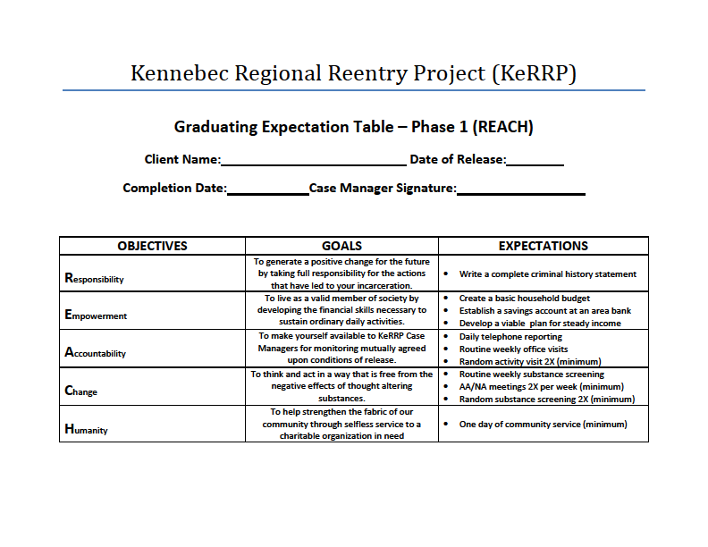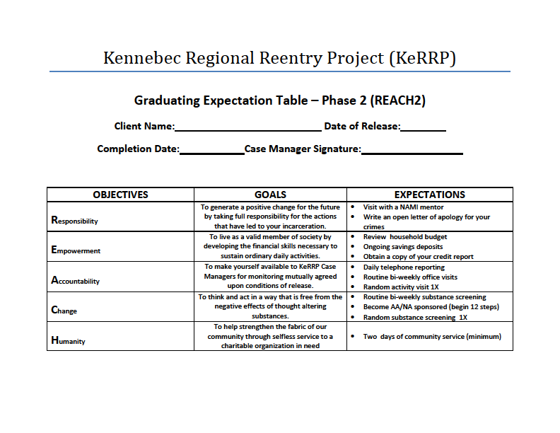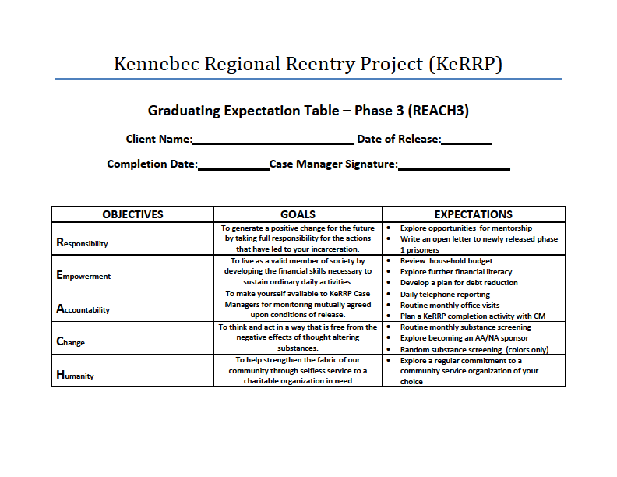

Appendix B

The Kennebec Regional Reentry Project is a multi-agency Community Confinement Monitoring program that is designed to help you get on your feet, and exit the legal system for the last time. This cooperative effort is the first of its kind in the State of Maine. Each agency brings a unique function to the re-entry plan, and acts in accordance with the vision of your successful transition toward a responsible, pro-social lifestyle.

We would like you to take a minute to acknowledge the following agencies for their part in your successful transition:

* Kennebec County Sheriff’s Office
* Crisis and Counseling Centers
* NAMI of Maine
* Hornby Zeller Associates
* Maine Pretrial Services
* Maine Department of Corrections Probation and Parole
* Kennebec County District Attorney’s Office
* Maine Judicial System
* Maine Board of Corrections

CONGRATULATIONS AND BEST OF LUCK!